PRACTICAL 1

1. WAP to demonstrate the attributes of <body>

<html>

<head>

<title>KRIPA JOSHI</title>

</head>

<body bgcolor=#EF5500 text="purple">

<h1> sunset is very calming</h1>

</body>

</html>

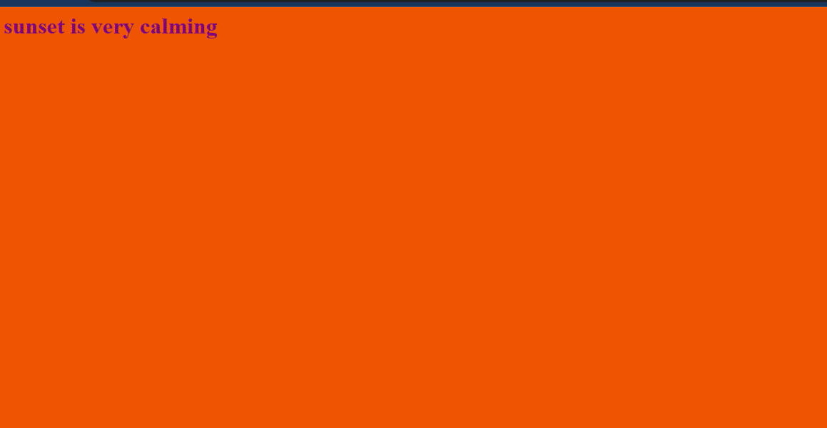

<html>

<head>

<title>KRIPA JOSHI</title>

</head>

<body background="sunset.jpg",text="purple">

<h1> sunset is very calming</h1>

</body>

</html>



1. WAP TO DEMONSTRATE TEXT FORMATTING TAGS

<html>

<head>

<title> text formatting</title>

</head>

<body>

<b>this makes the text bold</b><br><br>

<big>this makes the text big</big><br><br>

<small>this makes the text small</small><br><br>

<strike>this tag strikes the sentence</strike><br><br> byeee<sub>23</sub><br><br> hello<sup>25</sup><br><br>

<u>this tag underlines the text</u><br><br>

<tt>defines teletype or monospaced text </tt><br><br> it is <del>not</del> used to delete text <br><br>

it is <ins>not</ins> used to insert text <br><br>

it is used to <em>emphasize</em> the text <br><br>

it used to highlight <strong> important</strong> text<br><br>

<abbr title="abbreviation">abbr</abbr>

</body>

</html>

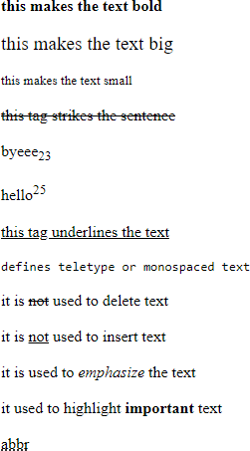

1. WAP TO DEMONSTRATE BLOCK FORMATTING TAGS

<html>

<head>

<title> block formatting</title>

</head>

<body>

<h1>h1 tag </h1>

<h2>h2 tag</h2>

<h3>h3 tag</h3>

<h4>h4 tag </h4>

<h5>h5 tag </h5>

<h6>h6 tag </h6>

<blockquote>blockquote</blockquote>

<br>br tag is used to go to next line <br>

<hr align="center" width=50% noshade size=50px>

<p> this is a paraghraph </p>

<div align="center">this divides the page into section</div>

<span style="color:purple">used to group inline elements and apply sheets</span>

</body>

</html>

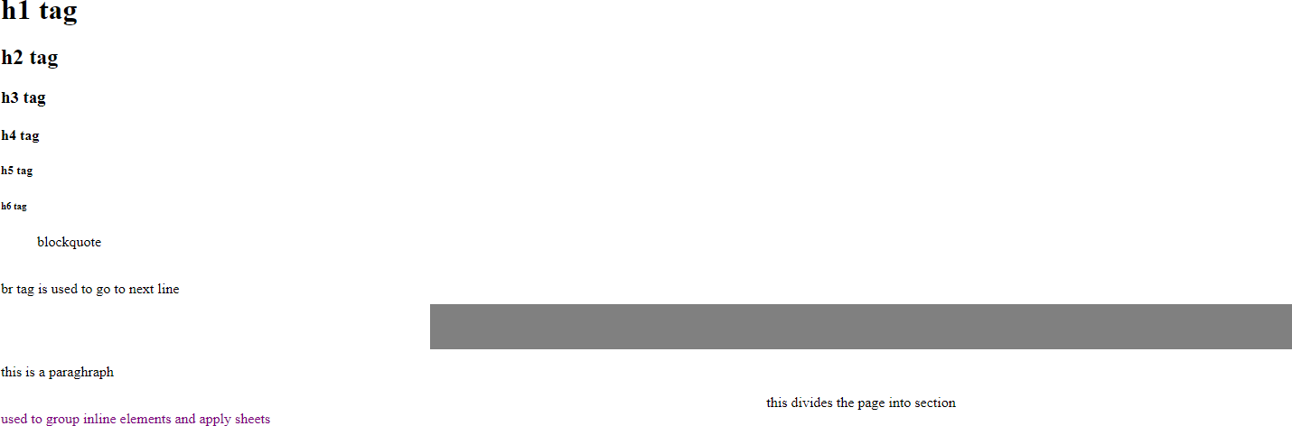

Practical 2

1. Demonstrate all the attributes of <img>

<html>

<head>

<title>attributes of image tag</title>

</head>

<body>

<img src="sunset.jpg" width="200px" alt="sunsett" align="center" hspace="300px" vspace="300px">

</body>

</html>



1. Demonstrate img map having 3 different areas defined in it

<html>

<title> image map</title>

<head>

</head>

<body>

<img src="sunset.jpg" height="1000px" width="1000px" usemap="#m1">

<map name="m1">

<area shape="circle" coords="200,200,50" href="textformatting.html">

<area shape="rect" coords="100,200,150,250" href="blockformatting.html">

<area shape="poly" coords="400,400,250,250,350,400" href="background.html">

</map>

</body>

</html>



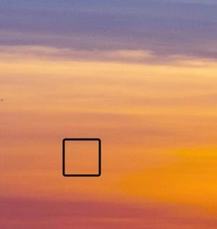



PRACTICAL 3

1. Demonstration of text based navigation hyperlinks Prac3a.html

<html>

<title>Prac 3a</title>

<head>

</head>

<body>

<a href="a.html">Click here</a>

</body>

</html>



a.html

<html>

<title>a</title>

<head>

</head>

<body>

<a href="Prac3a.html">Back to original page</a>

</body>

</html>



1. Demonstration of graphic based navigation hyperlinks Prac3b.html

<html>

<title>Prac 3b</title>

<head>

</head>

<body>

<a href="a.html"><img src="dog vertical.jpg" width="250px" height="250px" alt="Dog image"></a>

<a href="a.html"><img src="1a(i).jpg" width="250px" height="250px" alt="image"></a>

<a href="a.html"><img src="1a.png" width="250px" height="250px" alt="image"></a>

<a href="a.html"><img src="bluehills horizontal.jpg" width="250px" height="250px" alt="image"></a>

</body>

</html>



a.html

<html>

<title>a</title>

<head>

</head>

<body>

<a href="Prac3b.html">Back to original page</a>

</body>

</html>



1. Demonstration of all list tag along with attributes Unordered List

<html>

<title>Unordered List</title>

<body>

<ul type="circle">

<li>C++</li>

<li>Pyton</li>

<li>Java</li>

</ul>

<ul type="square">

<li>C++</li>

<li>Pyton</li>

<li>Java</li>

</ul>

<ul type="disc">

<li>C++</li>

<li>Pyton</li>

<li>Java</li>

</ul>

</body>

</html>



Ordered List

<html>

<title>Ordered List</title>

<body>

<ol start="5">

<li>Apple</li>

<li>Orange</li>

<li>Mango</li>

</ol>

<ol type='I'>

<li>Apple</li>

<li>Orange</li>

<li>Mango</li>

</ol>

<ol reversed>

<li>Apple</li>

<li>Orange</li>

<li>Mango</li>

</ol>

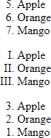

1. Demonstration of named anchor

<html>

<title>Prac 3d</title>

<body>

<a href="Prac 3d#ref">References<br></a>

<a href="Prac 3d#intro">Introduction<br></a>

<a href="Prac 3d#hist">History<br></a>

<a name="ref"> References:<br>

This are the references

</a>

<a name="intro"> Intoduction:<br>

This is the introduction

</a>

<a name="hist"> History:<br>

</a>

</body>

</html>

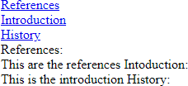

PRACTICAL 4

1. WAP to demonstrate external style sheet. use attributes letter spacing, word spacing, color and text-align with three different tags

Prac4a-html.html

<html>

<head>

<title>External Stylesheets</title>

<link type="text/css" rel="stylesheet" href="a.css"">

</head>

<body>

<h1>It is raining today</h1>

</body>

</html>

a.css h1{

letter-spacing:5px; word-spacing:2px; color:red;

text-align:center;

}



1. Write an HTML code to demonstrate id and class selector. Use any 4 class attributes

<html>

<title>Id and Class Attribute</title>

<head>

<style>

.p1{

color:green;font-size:24px

} #p2{

text-decoration:underline;background-color:yellow

}

</style>

</head>

<body>

<b class="p1"> Font is bold and green </b><br>

<b id="p2">Text is bold and underlined</b>

</body>

</html>



1. Create an HTML file will all the 3 types of Stylesheets Prac4c-html.html

<html>

<title>Id and Class Attribute</title>

<head>

<link type="text/css" rel="stylesheet" href="a.css"">

<style>

.p1{

color:lightblue;font-size:34px

}

#p2{

text-decoration:underline;background-color:yellow

}

</style>

</head>

<body>

<b class="p1"> Font is bold and blue </b><br>

<b id="p2">Text is bold and underlined</b><br>

<p style="font-size:18px;color:blue">This is a paragraph</p>

</body>

</html>

a.css h1{

letter-spacing:5px; word-spacing:2px; color:red;

text-align:center;

}

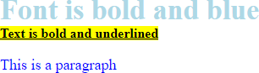

PRACTICAL 5

A) WAP to demonstrate tables

<html>

<title>Prac5a</title>

<head></head>

<body>

<table border=1>

<tr>

<th>ROll No</th>

<th>FN</th>

<th>LN</th>

</tr>

<tr>

<td>01</td>

<td>A</td>

<td>B</td>

</tr>

<tr>

<td>02</td>

<td>C</td>

<td>D</td>

</tr>

<tr>

<td>03</td>

<td>X</td>

<td>Y</td>

</tr>

</table>

</body>

</html>

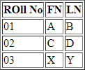

B)

<html>

<title>table2</title>

<body>

<table cellspacing="30" border=1>

<tr align="center">

<td colspan="8">1</td>

</tr>

<tr align="center">

<td colspan="4">2</td>

<td colspan="4">3</td>

</tr>

<tr align="center">

<td colspan="2">4</td>

<td colspan="2">5</td>

<td colspan="2">6</td>

<td colspan="2">7</td>

</tr>

<tr align="center">

<td> 8 </td>

<td> 9 </td>

<td> 10 </td>

<td> 11 </td>

<td> 12 </td>

<td> 13 </td>

<td> 14 </td>

<td> 15 </td>

</tr>

<tr align="center">

<td colspan="8"> 16 </td>

</tr>

</table>

</body>

</html>

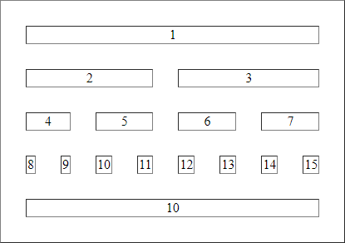

C)

<html>

<title>Prac5c</title>

<head></head>

<body>

<table border=1>

<tr align="center">

<td colspan="3">BSC.IT</td>

</tr>

<tr align="center">

<td colspan="2">Main</td>

<td>AC</td>

</tr>

<tr align="center">

<td>DCN</td>

<td rowspan="2">Linux</td>

<td rowspan="2">Web</td>

</tr>

<tr align="center">

<td>Comm</td>

</tr>

<tr align="center">

<td rowspan="2">Java</td>

<td>Program</td>

<td rowspan="2">Adv. Web</td>

</tr>

<tr align="center">

<td>OOP</td>

</tr>

</table>

</body>

</html>

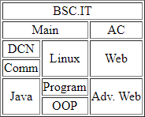

PRACTICAL 6

Q) Write an HTML code to demonstrate all the controls of a form

<html>

<head><title>Forms</title>

</head>

<body>

<form name='f1' method='post'>

<h1>Registrantion form </h1><br>

Enter Name<input type='text' name='t1' maxlength='50' required><br><br> Enter password<input type='password' id='p1'><br><br>

Gender:<input type='radio' name='r1' value='M'>Male

<input type='radio' name='r1' value='F'>Female

<input type='radio' name='r1' value='T'>Other<br><br> Age:<input type='number' name='n1'><br><br>

DOB:<input type='date' name='dob'><br><br> Address:<input type='text'><br><br>

color<input type='color'><br><br>

Range<input type ='range'><br><br> Select City:

<select>

<option value='Mumbai'>Mumbai</option>

<option value='Thane'>Thane</option>

<option value='Nagpur'>Nagpur</option>

<option value='Pune'>Pune</option>

</select><br><br>

Profile<input type='file' name='profile' accept='.jpg,.jpeg,.png'><br><br>

<input type='Submit' name='Submit' value='Submit'>

<input type='Reset' name='Reset' value='Reset'>

</form>

</body>

</html>

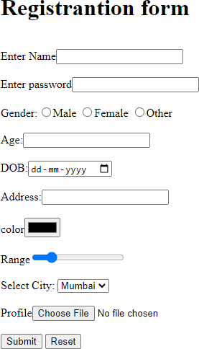

PRACTICAL 7

Q1) WRITE AN HTML CODE TO CHANGE THE BACKGROUND COLOR OF THE FORM USING RADIO BUTTON

<html>

<title> Javascript</title>

<head>

<script type="text/javascript"> function red()

{

document.body.style.background="red";

}

function yellow()

{

document.body.style.background="yellow";

}

function pink()

{

document.body.style.background="pink";

}

function green()

{

document.body.style.background="green";

}

</script>

</head>

<body>

<input type="radio" name="red" value="Red" onclick="red()">Red<br>

<input type="radio" name="yellow" value="Yellow" onclick="yellow()">Yellow<br>

<input type="radio" name="pink" value="Pink" onclick="pink()">Pink<br>

<input type="radio" name="green" value="Green" onclick="green()">Green<br>

</body>

</html>

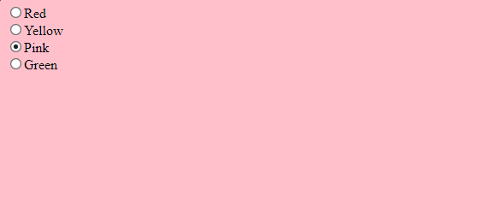

Q2) WRITE A PROGRAM TO CHANGE THE CAPTION OF THE BUTTON ON MOUSE CLICK

<html>

<head>

<script type="text/javascript"> function mousedown()

{

document.f1.b1.value="Enter";

}

function mouseup()

{

document.f1.b1.value="Clear";

}

</script>

</head>

<body>

<form name="f1">

<input type="button" name="b1" value="Click" onMouseDown="mousedown()" onMouseUp="mouseup()"><br>

</form>

</body>

</html>



Q3) WAP TO DEMOSTRATE STRING FUNCTIONS FOR THE FOLLOWING: TO CONVERT TEXT TO UPPERCASE

TO CONVERT TEXT TO LOWERCASE TO REPLACE CHARACTER

TO FING SUBSTRING

<html>

<head>

<script type="text/javascript"> function upper()

{

var a=prompt("Enter a value: "); var b=a.toUpperCase(); alert("The message is "+b);

}

function lower()

{

var a=prompt("Enter a value: "); var b=a.toLowerCase(); alert("The message is "+b);

}

function replace()

{

var e=document.getElementById("u3").value; var f=e.replace(e,"Hello");

alert("The message replaces with "+f);

}

function substring(){

var p=prompt("Enter a value: "); var q=p.substring(0,4); alert("The substring is "+q);

}

</script>

</head>

<body>

<input type="button" value="UpperCase" onClick="upper()"><br><br>

<input type="button" value="LowerCase" onClick="lower()"><br><br>

<input type="text" id="u3" value="Enter value" onBlur="replace()"><br><br>

<input type="button" value="Substring" onClick="substring()">

</body>

</html>

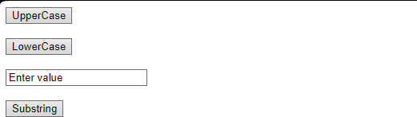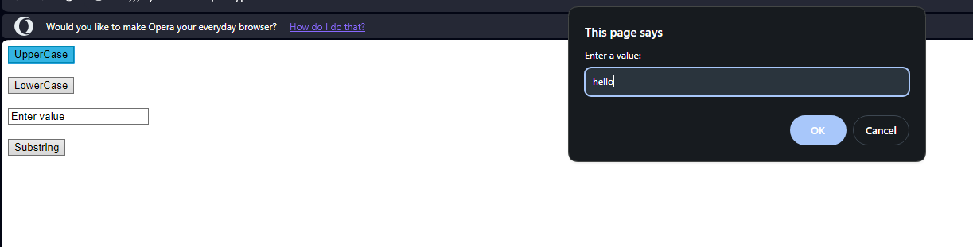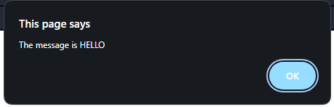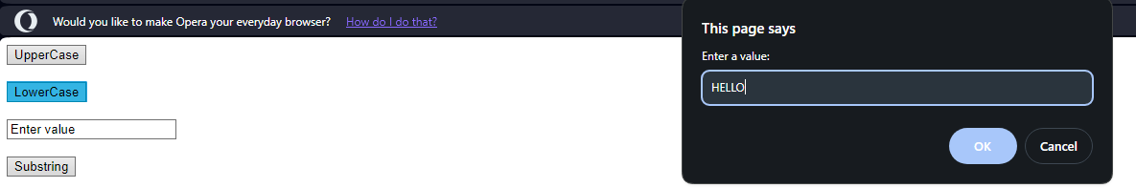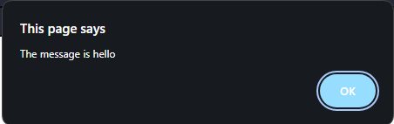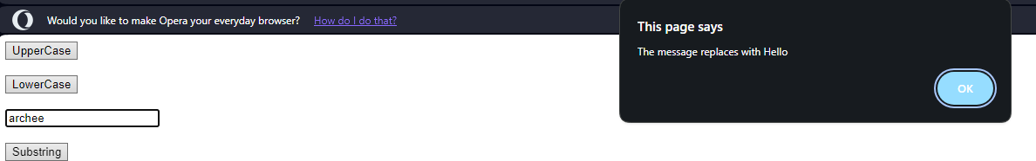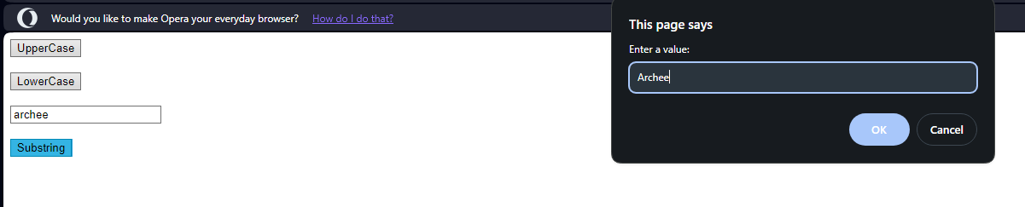

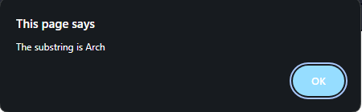

Q4) WAP TO DISPLAY SUM OF SQUARE OF TWO NUMBERS USING PROMPT

<html>

<head>

<script type="text/javascript"> function add(){

var a=prompt("Enter value1: "); var b=prompt("Enter value2: "); x=parseInt(a);

y=parseInt(b); z=x*x+y*y;

alert("Sum of square of "+x+y+" is "+z);

}

</script>

</head>

<body>

<input type="button" name="button" value="Add" onClick="add()">

</body>

</html>

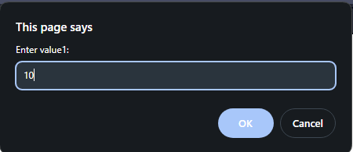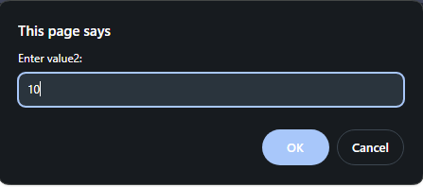

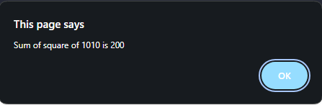

PRACTICAL 8 Q1) WAP TO DEMOSTRATE KEY PRESS EVENT

<html>

<head>

<script type="text/javascript"> function keypress()

{

var a=document.getElementById("l1").value; alert("You have pressed "+a);

}

</script>

</head>

<body>

<input type="text" id="l1" value="Enter Value" onKeyPress="keypress()"><br>

</body>

</html>

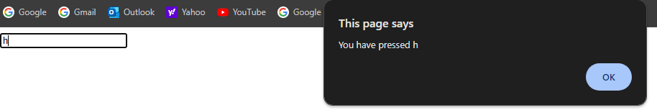

Q2) DEMOSTRATE THE USE OF DOCUMENT.GETELEMENTBYID AND INNER HTML

<html>

<head>

</head>

<body>

<b id="b1">Hello World!</b><br><br>

<input type="button" value="Change" onClick="document.getElementById('b1').innerHTML='Hello'"><br>

</body>

</html>



Q3) WAP TO DISPLAY TOMORROWS DAY IN JAVASCRIPT

<html>

<head>

<script type="text/javascript"> function abc()

{

x=new Date(); document.write(x.getDate()+1);

}

</script>

</head>

<body>

<input type="submit" value="Check" onclick="abc()">

</body>

</html>



PRACTICAL 9

Q1) WAP TO DISPLAY FIRST 100 OADD NUMBERS USING FOR LOOP IN PHP

<?php

$num=0; for($i=1;$num<100;$i++){ if($i%2!=0){

echo $i."<br>";

$num++;

?>

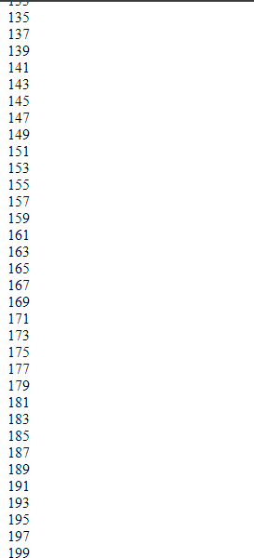

Q2) WAP TO ACCEPT NAME,AGE,CITY IN HTML AND DISPLAY THE CONTENT IN PHP

prac9.html

<html>

<head>

</head>

<body>

<form action="disp.php" method="post"> Name:<input type="text" name="name"><br><br> Age:<input type="text" name="age"><br><br>

City:<input type="text" name="city"><br><br>

<input type="submit" value="OK">

</form>

</body>

</html>

disp.php

<?php

echo "Name is ";

echo $_POST["name"]."<br>"; echo "Age is ";

echo $_POST["age"]."<br>"; echo "City is ";

echo $_POST["city"]."<br>";

?>

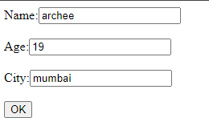

Q3) WAP TO DEMOSTRATE STRING FUNCTIONS IN PHP

<?php

$string = "Hello World!";

echo "1. Length of the string: " . strlen($string) . "<br>";

echo "2. Number of words: " . str_word_count($string) . "<br>";

echo "3. Reversed string: " . strrev($string) . "<br>";

$word = "World";

echo "4. Position of 'World' in the string: " . strpos($string, $word) . "<br>";

$replace = str_replace("World", "PHP", $string);

echo "5. Replacing 'World' with 'PHP': " . $replace . "<br>";

echo "6. Uppercase string: " . strtoupper($string) . "<br>";

echo "7. Lowercase string: " . strtolower($string) . "<br>";

echo "8. Substring (first 5 characters): " . substr($string, 0, 5) . "<br>";

echo "9. Repeat string 3 times: " . str_repeat("Hello ", 3) . "<br>";

$trimString = " Hello World! ";

echo "10. Trimmed string: '" . trim($trimString) . "'<br>";

?>

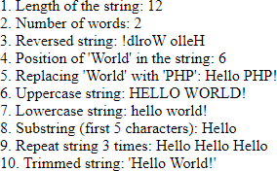

PRACTICAL 10 Q1) WAP TO DEMOSTRATE MULTIMEDIA CONTENT IN HTML AUDIO

<html>

<head><title>audio</title></head>

<body>

<audio controls autoplay preload="auto" loop="-1">

<source src="audio1.mp3" type="audio/mp3"> Your browser does not support the audio tag.

</audio>

</body>

</html>



VIDEO

<html>

<head><title>video</title></head>

<body>

<video controls autoplay height="200 px" width="250 px" preload="auto" loop="4" muted>

<source src="video.mp4" type="video/mp4"> Your browser does not support the video tag.

</video>

</body>

</html>

